1. 
2. We have already index named “products” and we have already indexed a bunch of documents in it.
3. **Agenda**: How to add a new field to the mapping.
   1. We want to define a discount field with double data type.
4. 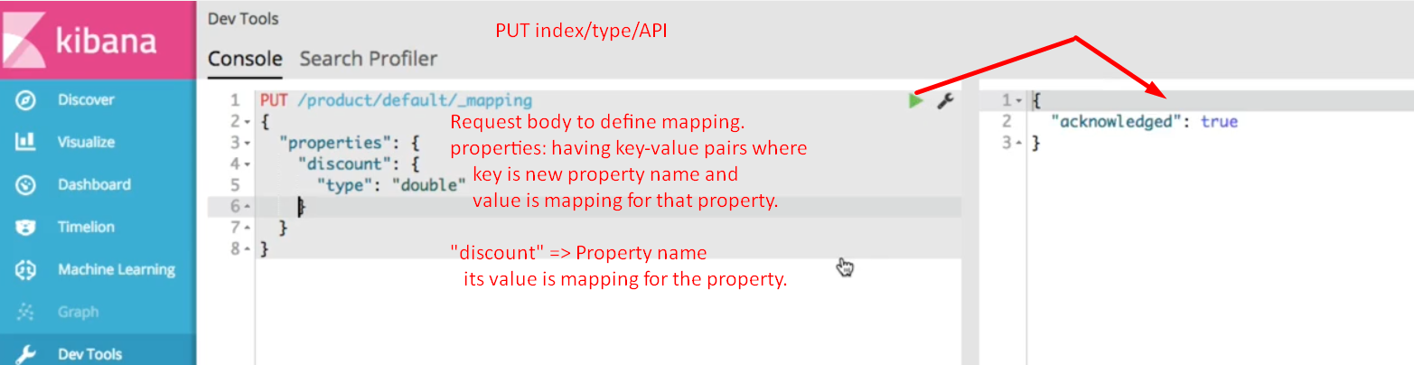
5. 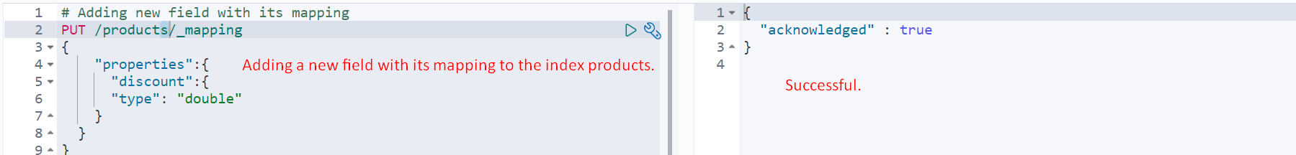
6. 